Ideation Phase
Empathize & Discover

Date | 31 October 2025
Team ID | NM2025TMID06949
Project Name | Laptop Request Catalog Item
Maximum Marks | 4 Marks

Empathy Map Canvas:
An empathy map for the Laptop Request Catalog Item focuses on the employee experience when requesting laptops an empathy map helps visualize what users say, think, do, and feel. It provides a deeper understanding of the user's needs and frustrations to guide solution design.
Below is the empathy map for the Service Catalog laptop request scenario.

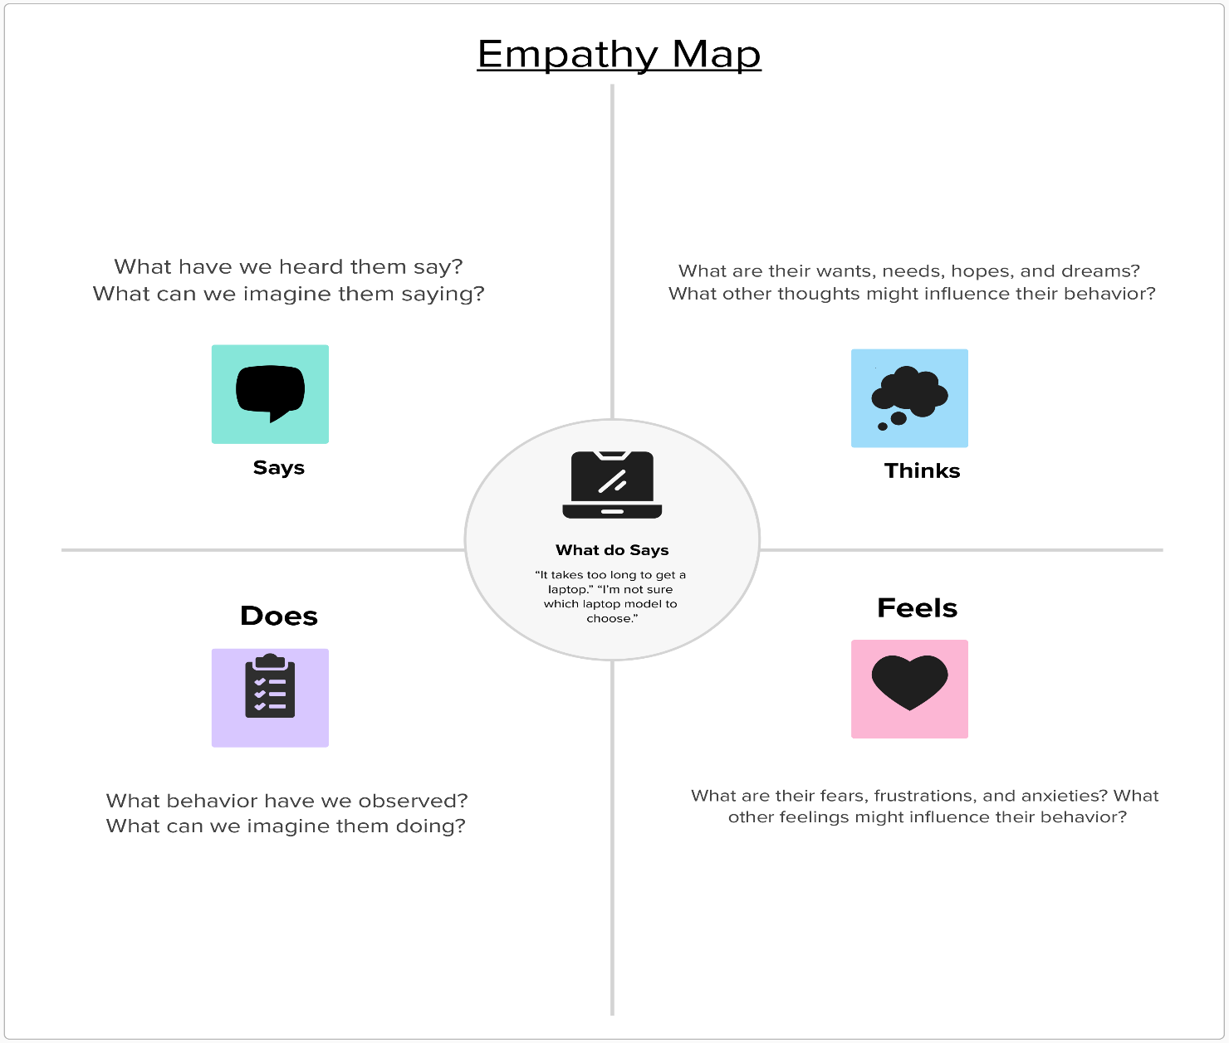

Reference: https://www.mural.co/templates/empathy-map-canvas

Laptop Service Catalog Item
